**Screen Shot for each year of your results on the Multi Year Stock Data**

**2014:**

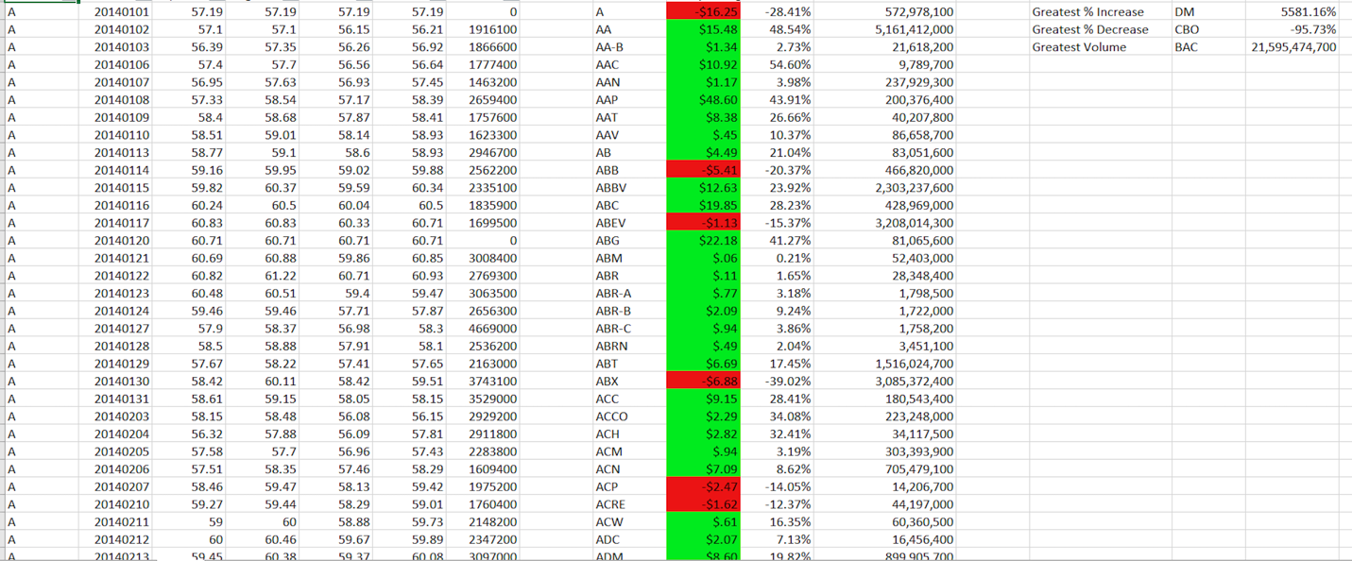

**2015:**

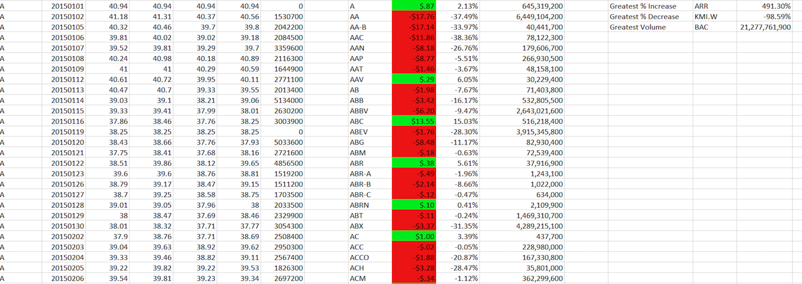

**2016:**

